The Engineering Design Process

Day 10: Lesson Quiz

Choose the letter of the best answer.

1. Which of the following pairs of statements correctly identifies the goals of science and engineering?

A. science: construct explanations of the natural world;   
engineering: address the needs of society

B. science: develop new technology to explore the natural world;   
engineering: apply mathematics to the study of the natural world

C. science: improve human quality of life;   
engineering: learn about the natural world

D. science: develop manmade systems;   
engineering: develop tools and machines

2. During which step of the engineering design process would a scientist publish a report in a scientific journal?

A. conduct background research

B. prepare preliminary designs

C. test a prototype

D. communicate results

3. The engineering design process may result in many solutions to a problem. Even after collecting evidence, engineers may disagree about which solution is the best. Which of the following is not a valid reason to conclude that a solution is the best one?

A. The solution has the lowest financial cost.

B. The solution was the engineer’s first idea.

C. The solution uses materials that are readily available.

D. The solution has the best ratio of environmental cost and benefits.

4. Which of the following statements about empirical evidence and conclusions is correct?

A. Empirical evidence is collected through observation, and conclusions are the results of interpreting empirical evidence.

B. Empirical evidence is collected during experiments, and conclusions are collected during engineering processes.

C. Empirical evidence is based on the bias and opinions of scientists, and conclusions are based on facts.

D. Empirical evidence is important for engineering processes, and conclusions are important for scientific processes.

5. A digital scale is an example of technology used to gather data during the engineering design process. Look at the digital balance and sample below.

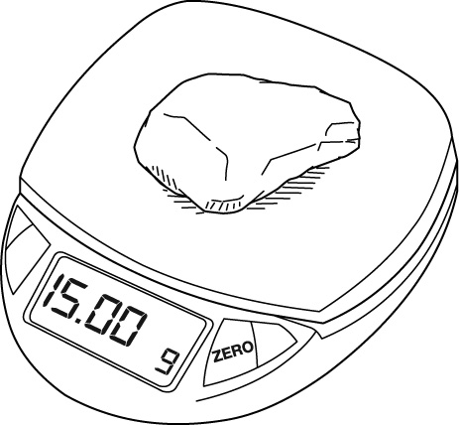

What should the scientist record as the mass of the sample?

A. 15

B. 15.00

C. 15 g

D. 15.00 g